

|  |  |  |  |  |  |  |  |  |
| --- | --- | --- | --- | --- | --- | --- | --- | --- |
|  | | | | | | | | |
|  | | **Custom Program**  Water Tracker  COS10009 – INTRODUCTION TO PROGRAMMING | | | | |  | |
|  |  | | | | | | |  |
|  | | | | Group 1  Student:  **Amirul Iman bin Amran**  (101234444)  Lecturer:  **Sim Kwan Hua** |  | | | |
|  | | | |  |  | | | |
|  | | | |  |  | | | |
|  | | |  | | |  | | |

**Table of Contents**

Overview 3

Objectives 3

Features 3

Flowchart 4

Screenshots 5

Functions 7

analysis function 7

draw function 7

mouse_over_button? function 7

button_down function 8

Data dictionary 8

Water_tracker.txt 8

goal.txt 9

Day.txt, Week.txt, Month.txt 9

# Overview

Water is essential to our life; drinking enough and the right quantity of water is vital to our health. But because of our bad memory, busy work, or too many little things, the day is ended before we drink enough water. Water tracker is a program that aims to help us keep track of our daily water consumption. Proper hydration gives many benefits that can improve our lifestyle. This program will allow us to develop good habits of water drinking. Just key in the amount of water you drink in ml, and Water Tracker will help analyze based on day, week, and months. You can also see if it reaches your daily goal, so can you get motivated and consistent throughout the day, week or months.

## Objectives

* Help users to track their daily intake
* Provide users with the record of the day, week, and months
* Encourage users to keep hydrated

## Features

* Update daily intake
* Track daily intake
* Set a daily intake goal
* Check the analysis of the day
* Check the analysis of the week
* Check the analysis throughout the year
* Graphs are used to convey the analysis
* Reset drinking history

# Flowchart

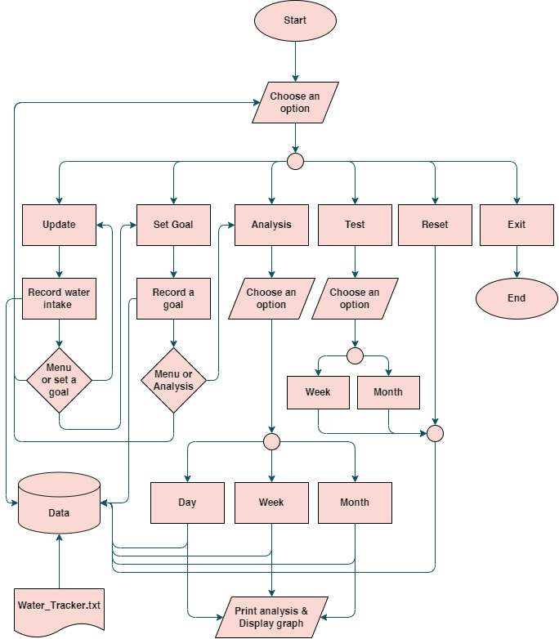

# Screenshots

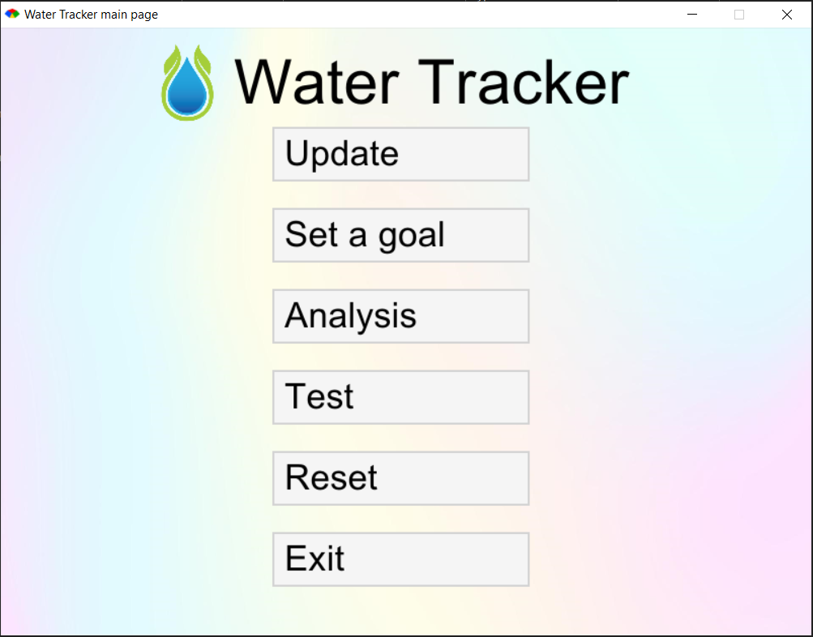

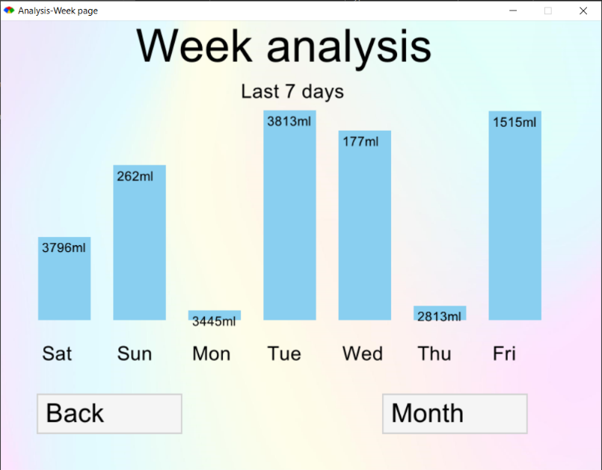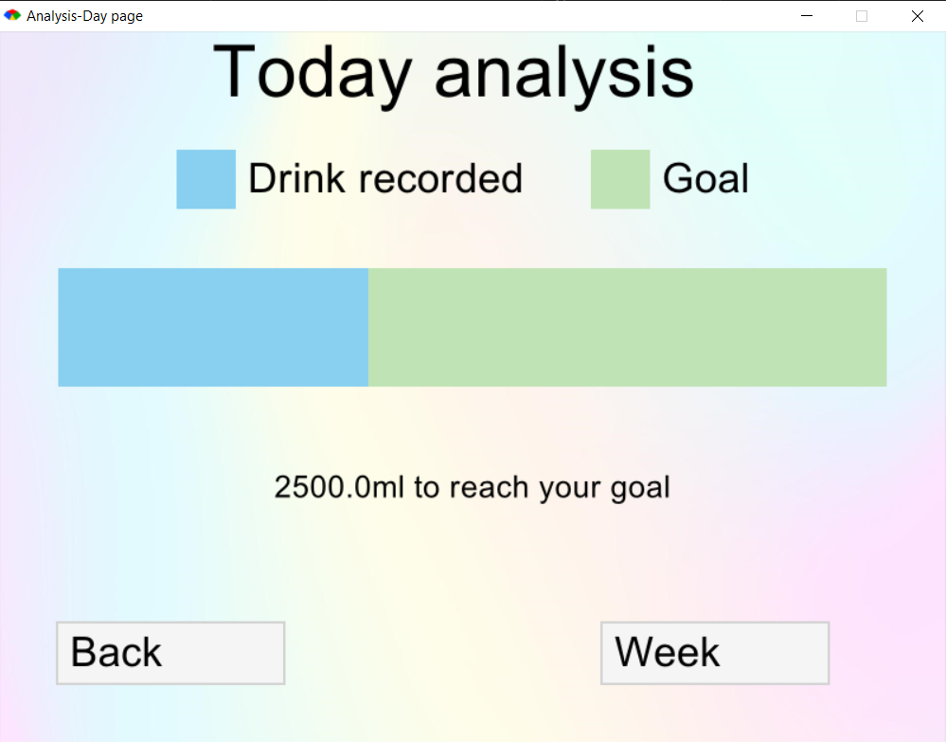

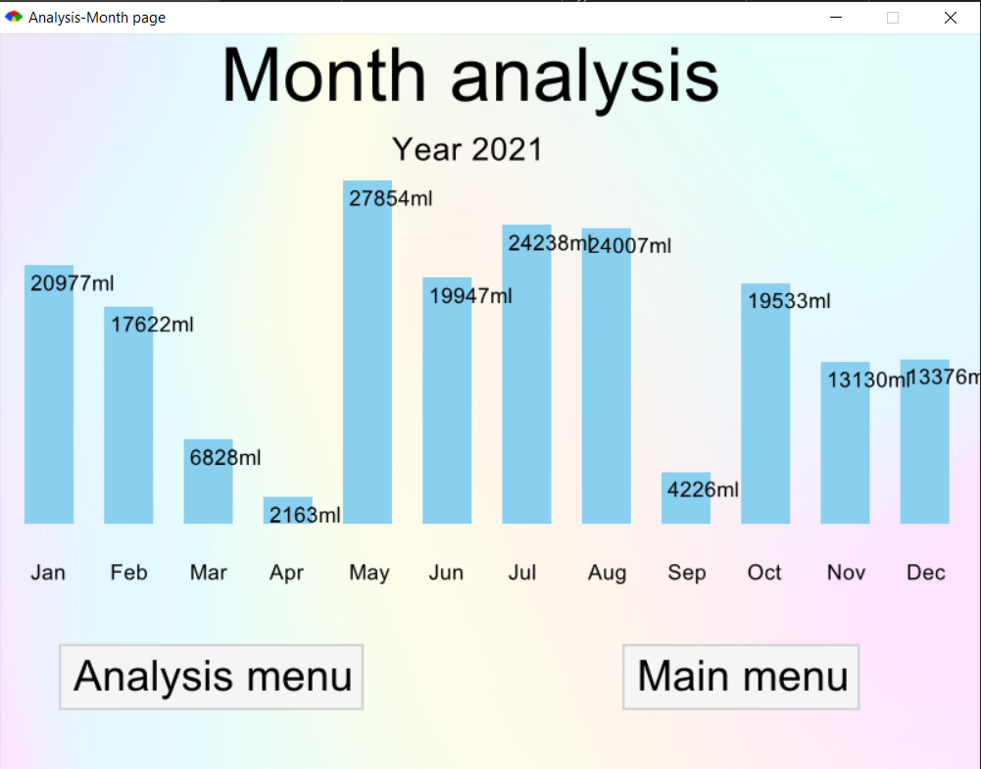

# Functions

This program was made using ruby alongside with Gosu library.

## analysis function

Analyze the data files to create an array that will, later on, pass the parameter to the draw function. The file that is analyzed is depended on the option. For instance, to analyze a week, this function will read and calculate from the Week.txt file. The same goes for other options. After data is received, it will calculate and provide the newly configured data to draw the function.

## draw function

Draw function creates background image using a PNG file and text with different sizes. It also makes buttons along with its tag and outlines that change whenever the cursor hovers on it. Another vital role of this function is drawing the graph based on the data received from the analysis function. draw function then creates graph bars using the data that contains the x and y coordinates, width, and height of each graph bar.

## mouse_over_button? function

It receives two parameters of x and y coordinates of the cursor location. This function is assigned to the update function, which uses the data to do the hover effect.

**update function**

This function keeps track of the cursor's real-time location on the program area. This function makes it possible to do the hover effect, changing the button outline from gray to black. It retrieves inputs using mouse_over_button? function to determine whether the button should be outlined with black color or not.

## button_down function

Allows the users to pick an option and link to another class. For example, if the users choose a button, this function will direct the users to a specific class based on the option.

# Data dictionary

Multiple external files are used to store and analyze the data inserted by the users. All the files are located in the cache folder. Every time the user updates their water intake, it will store 5 components: a day in number, year, month, day of the week, and (water intake)ml. The program will then analyze and filter the data that must be calculated and displayed on the program.

## Water_tracker.txt

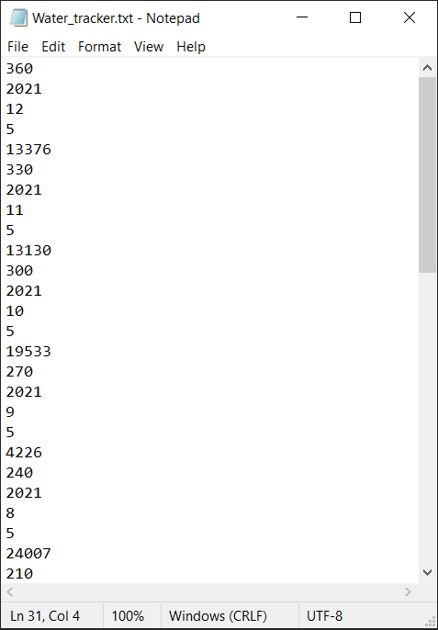

Day

Year

Month

Day of the week

ml

Day in number, 365 days

Year

Month

The number of the day, ex. 0 = Sunday

(Water intake) ml

## goal.txt

This file contains the daily intake goal that later on will be used to determine whether the user has reached the goal or not. It is also used to ensure that the user has set a daily intake goal. Otherwise, the user will be prompted to select a daily intake goal before updating their daily intake. Users can simply delete and change their goals whenever they want.

## Day.txt, Week.txt, Month.txt

These files store data that is used explicitly by the *analysis function* in the program to make an analysis of the data. The data is curated from the Water_tracker.txt file to make the analysis process more manageable. Each file has its own purpose; Day.txt is for daily analysis, Week.txt is for week analysis, and Month.txt is for week analysis.

